Khulna University of Engineering & Technology

Course Title : Peripherals & Interfacing Laboratory

Course No : CSE 3104

Project Name : Smart Garage

Submitted To,

##### Md. Repon Islam

##### Lecturer, Department of CSE,KUET

##### Md. Badiuzzaman Shuvo

##### Lecturer, Department of CSE,KUET

Submitted By,

Farhana Tazrin Proma

Roll : 1907041

Zobayer Abedin

Roll : 1907045

3rd Year 1st Semester

**Objectives :**

1. To implement a smart garage system using ARDUINO UNO.
2. To learn to combine all the knowledges acquired in this course into a practical real life application.
3. Design and implement an automated door system for the smart garage that opens and closes based on the availability of vacant parking spaces.
4. Develop a sensor-based mechanism to detect the presence of a car outside the garage door and determine if there are any vacant parking areas within the garage.
5. Integrate the sensor system with the door control mechanism to enable automatic door opening only when there is an available parking space inside the garage.
6. Implement a buzzer system that alerts the driver with a sound indicating the status of parking availability, specifically whether there are any vacant parking spaces or not.
7. To create an IR display that indicates the availability of parking spaces within the garage.

**Introduction :**

Our project provides an overview of the smart garage system, focusing on few key features. The purpose of this report is to provide an overview of the smart garage system developed as part of the Peripheral Project. The smart garage system incorporates various features to automate the process of opening and closing the garage door based on the availability of parking spaces inside the garage. Additionally, an infrared (IR) display is used to indicate the availability of parking spaces to the driver.This report will discuss the implementation of these features, their benefits, and potential considerations.

**Apparatus Required :**

1. Arduino UNO
2. Buzzer
3. Wiring and Connectors
4. Infrared (IR) Sensors
5. LCD Display
6. Power Supply(2*3.7V)
7. LED

**Working Principle :**

1.Automated Door System: The automated door system is equipped with sensors that detect the presence of a vehicle approaching the garage entrance. When a car comes near the garage, the sensors detect its presence.

2. Parking Space Availability Check: Once the car is detected, the system checks the availability of parking spaces inside the garage. It determines whether there are any vacant parking areas or if the garage is already full.

3.Door Opening Decision: If there are vacant parking spaces inside the garage, the system activates the mechanism to open the garage door. The door will remain closed if there are no available parking spaces.

4.Buzzer Sound Feedback (No Available Space): If there are no vacant parking spaces, the system triggers a buzzer sound to indicate to the driver that there is no empty parking space in the garage. This alert ensures that the driver is aware that they cannot enter the garage at that moment.

5.Door Opening and Buzzer Sound (Available Space): If there are vacant parking spaces inside the garage, the system initiates the process of opening the garage door. Simultaneously, a buzzer sound is generated to notify the driver that the door is in the process of opening. This sound acts as an audible signal for the driver to proceed safely into the garage.

6. LCD Display Status (Available Space): As the car attempts to enter the garage, an infrared (IR) display located near the garage entrance shows the numerical value "0" to indicate the availability of parking spaces. This display serves as a visual confirmation to the driver that there are vacant parking areas inside the garage.

7.LCD Display Status (No Available Space): Conversely, if there are no vacant parking spaces in the garage, the IR display shows a cross sign to indicate that the garage is full. This display informs the driver that they should not enter as there are no parking spaces available at that time.

**Software Design :**

**Pseudocode:**

Initialize the required libraries and variables

Setup:

Attach the servo motor to the designated pin

Initialize the serial communication

Set the pinMode for IR sensor input, buzzer, and LEDs

Loop:

Read the status of each IR sensor and store it in the status array

Initialize and configure the LCD display

Print the status of the parking spaces on the LCD display

Check if the door is open:

If true, return from the loop (exit the loop)

Check the status of the parking spaces:

If all spaces are unoccupied:

Turn on the red LED

Display a message on the LCD indicating no available parking spaces

Activate the buzzer for a few seconds

Turn off the red LED

Else:

Turn on the green LED

Display a welcome message on the LCD

Activate the buzzer briefly

Open the servo motor gradually to 80 degrees

Delay for 1.5 seconds

Activate the buzzer briefly

Close the servo motor gradually to 0 degrees

Turn off the green LED

Repeat the loop.

**Hardware Design :**

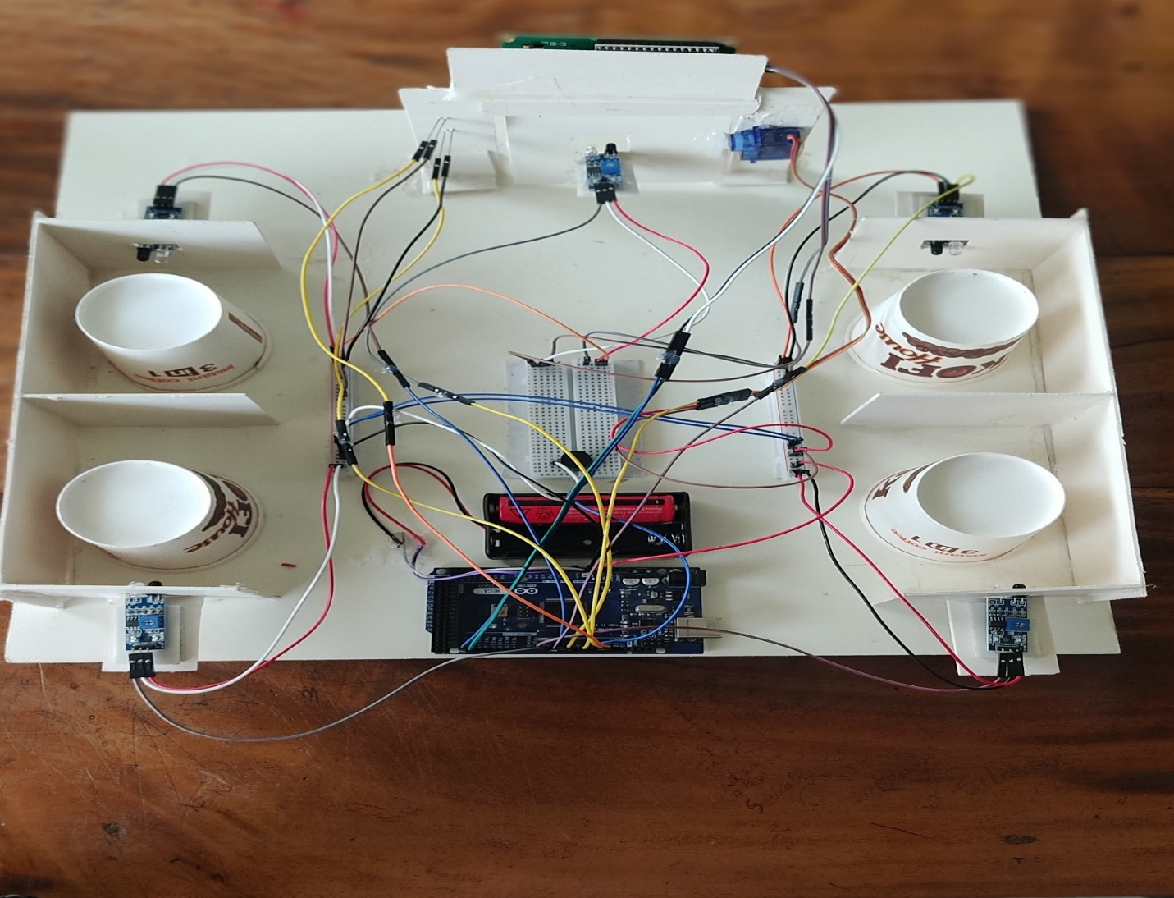

Fig-1: Smart Garage System

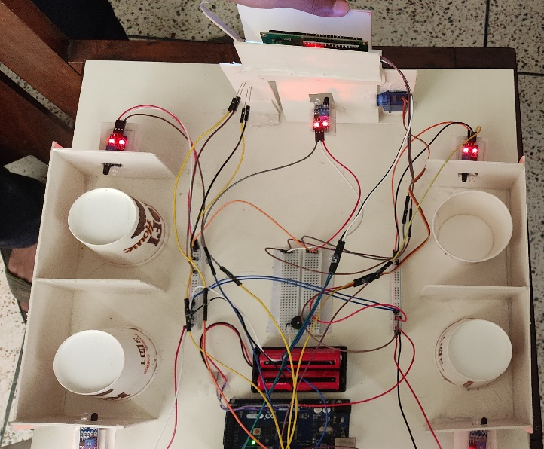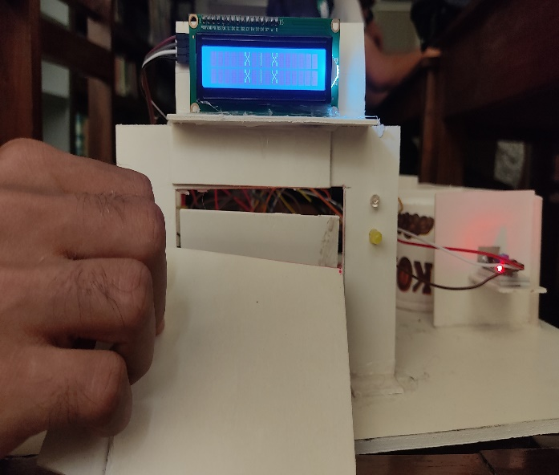 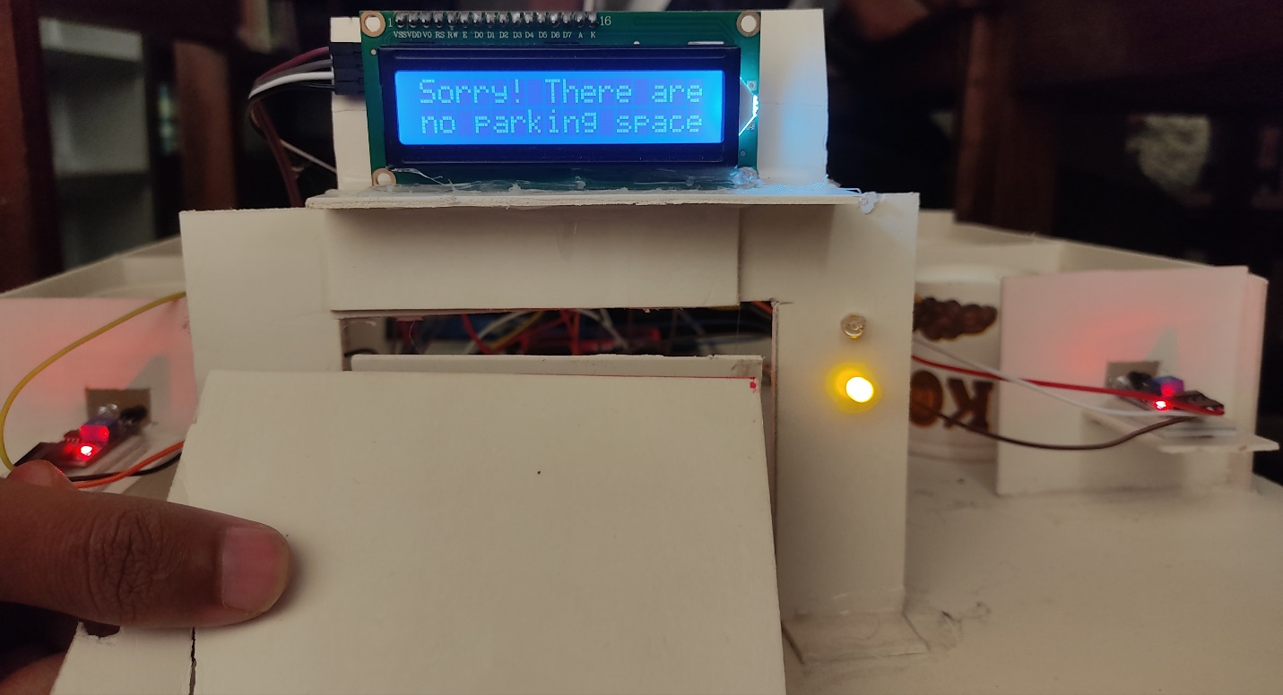

Fig-2: When there is no vacant parking area

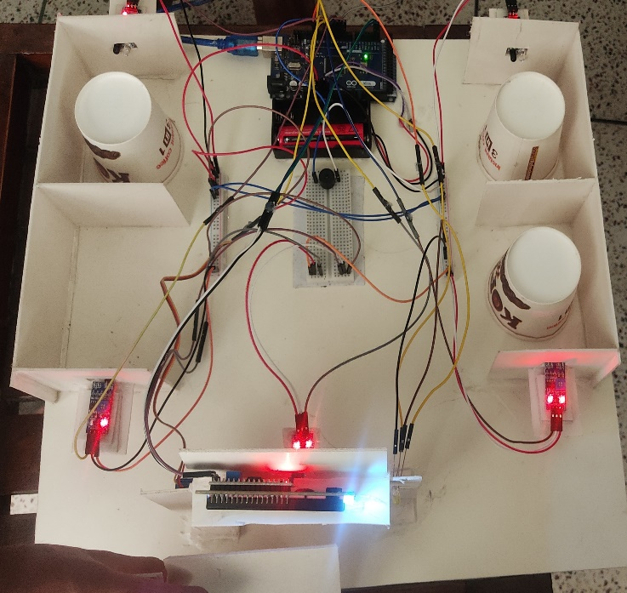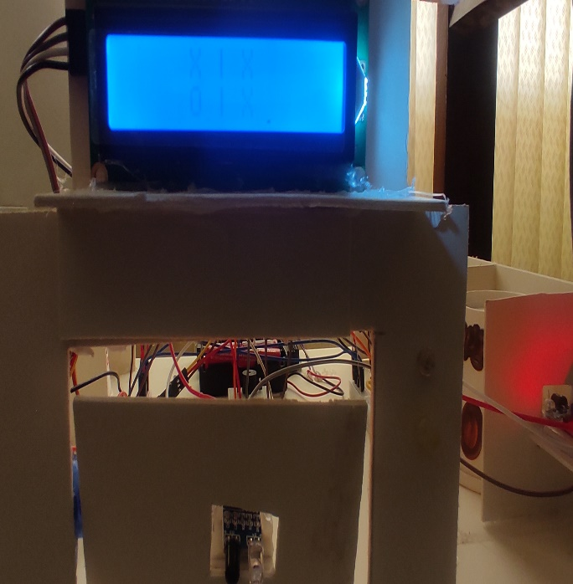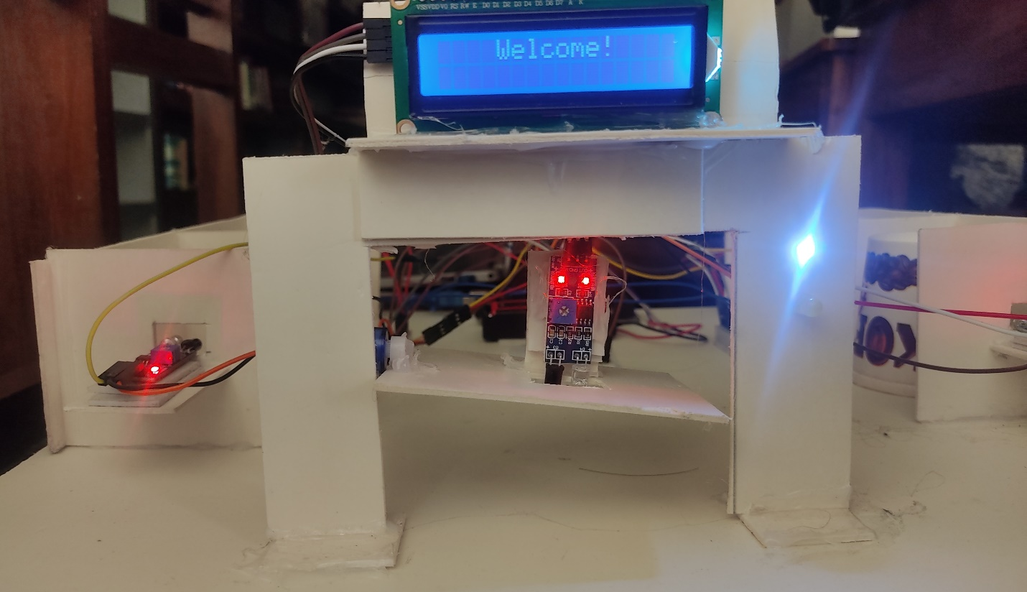

Fig-3: When there is any vacant parking area

**System Testing :**

**White Box Testing:**

1. Automated Door System Testing:

Test 1: Door Opening with Vacant Parking Space

Input: Car approaching the garage with vacant parking spaces inside.

Expected Output: The door should open automatically, and a buzzer sound should be triggered while the door is opening.

Test Steps:

Simulate a car approaching the garage.

Check if the door opens automatically.

Verify that the buzzer sound is triggered during the door opening process.

Test 2: Door Not Opening with No Vacant Parking Space

Input: Car approaching the garage with no vacant parking spaces inside.

Expected Output: The door should remain closed, and a buzzer sound should be triggered to indicate the unavailability of parking spaces.

Test Steps:

Simulate a car approaching the garage.

Verify that the door remains closed.

Check if the buzzer sound is triggered to indicate the unavailability of parking spaces.

Test 3: Car Entry Detection

Input: Car entering the garage.

Expected Output: The door should be opened, and the car should be able to enter safely.

Test Steps:

Simulate a car entering the garage.

Verify that the door opens automatically.

Ensure that the car can enter the garage safely.

2. IR Display Testing:

Test 4: Display "0" for Vacant Parking Space

Input: Car attempting to enter the garage with vacant parking spaces.

Expected Output: The IR display should show "0" to indicate vacant parking spaces, and the door should open.

Test Steps:

Simulate a car approaching the garage entrance.

Check if the IR display shows "0" when there are vacant parking spaces.

Verify that the door opens automatically.

Test 5: Display Cross Sign for No Vacant Parking Space

Input: Car attempting to enter the garage with no vacant parking spaces.

Expected Output: The IR display should show a cross sign to indicate no vacant parking spaces, and the door should remain closed.

Test Steps:

Simulate a car approaching the garage entrance.

Check if the IR display shows a cross sign when there are no vacant parking spaces.

Verify that the door remains closed.

**Black Box Testing:**

1. Test Scenario: Automated Door System

Test Case 1: Verify that when a car approaches the garage and there are vacant parking spaces, the door opens automatically.

Test Case 2: Verify that when a car approaches the garage and there are no vacant parking spaces, the door remains closed.

Test Case 3: Verify that when the door is opening, a buzzer sound is triggered to indicate the process.

2. Test Scenario: IR Display

Test Case 4: Verify that when a car attempts to enter the garage and there are vacant parking spaces, the IR display shows "0."

Test Case 5: Verify that when a car attempts to enter the garage and there are no vacant parking spaces, the IR display shows a cross sign.

Test Case 6: Verify that the IR display updates immediately when the availability of parking spaces changes.

3. Test Scenario: Integrated Functionality

Test Case 7: Verify that when the door is opening, and there are vacant parking spaces, the car can enter the garage.

Test Case 8: Verify that when the door remains closed due to no vacant parking spaces, the car cannot enter the garage.

Test Case 9: Verify that the buzzer sound is triggered only when the door is opening and there are no vacant parking spaces.

Test Case 10: Verify that the IR display and door operation are synchronized correctly.

**Experimental Results :**

In the "Vacant Parking Spaces" scenario:

The automated door system correctly opened the door when the car approached and there were vacant parking spaces available.

The buzzer sound was generated while the door opened, providing an audible signal to the driver.

The IR display showed "0," indicating that there were available parking spaces inside the garage.

In the "No Vacant Parking Spaces" scenario:

The automated door system did not open the door when the car approached, as there were no vacant parking spaces inside the garage.

The buzzer sound was generated to indicate the lack of parking spaces to the driver.

The IR display showed a cross sign, indicating that the garage was full and the car should not enter.

**Discussion:**

The implementation of an automated door system in the smart garage provides numerous advantages. Firstly, it eliminates the need for manual operation of the garage door, which improves convenience for the driver. As the car approaches the garage, the door opens automatically if there are vacant parking spaces inside. This feature saves time and effort for the driver, as they do not have to manually open and close the garage door.

Additionally, the system incorporates a buzzer sound to indicate the availability of parking spaces. When the door remains closed due to the unavailability of vacant spaces, a buzzer sound is triggered. This auditory feedback helps the driver quickly identify that there are no empty parking spaces in the garage. Conversely, when the door is opening, another buzzer sound is generated, alerting the driver that it is safe to proceed into the garage. These sound cues enhance the user experience and ensure effective communication between the system and the driver.

However, it is essential to consider potential challenges associated with the automated door system. For instance, the reliability and accuracy of the sensors used to detect the presence of a vehicle are crucial for the system's effectiveness. False readings or inconsistencies in detecting vehicles could lead to incorrect door operations. Therefore, extensive testing and calibration of the sensors should be conducted during the system's development to ensure its reliability.

IR Display for Parking Space Availability:

The use of an IR display to indicate parking space availability is a valuable feature in the smart garage system. By employing an easily visible display near the garage entrance, the system provides real-time information to the driver attempting to enter the garage.

When a car approaches the garage, the IR display shows "0" if there are vacant parking spaces, indicating that the driver can proceed into the garage. This visual cue allows for quick and intuitive decision-making, saving time for the driver. Conversely, if there are no available parking spaces inside the garage, the IR display shows a cross sign, indicating that the garage is full and the car should not attempt to enter. This feature helps avoid congestion and ensures efficient utilization of parking spaces.

It is worth noting that the accuracy and reliability of the IR display are critical. The display must always reflect the actual availability of parking spaces inside the garage. Any discrepancies could lead to confusion and potentially result in a car attempting to enter an already occupied garage. Therefore, regular maintenance and monitoring of the IR display's functionality are essential to ensure accurate information is conveyed to the driver.

**Conclusion:**

The peripheral project for the smart garage system successfully implements few key features.These features enhance convenience, efficiency, and organization within the garage environment. However, careful attention should be given to accuracy, safety, sensor placement, and display visibility during the implementation process. By incorporating these features, the smart garage system offers an advanced and user-friendly solution for automated garage management.

**References:**

1. https://www.arduino.cc/reference/en/